**Vyasa Arts & Science Women's College Subramaniapuram.**

**DEPARTMENT OF MATHEMATICS** **2023 - 2024**

**Voyage visit: ANALYSING INDIAN AGRICULTURAL CROP PRODUCTION (1997-2021)**

# TEAM LEADER

1. Rasmiya Habeeba P

# TEAM MEMBERS

1. Jasmine N
2. Geetha Lakshmi G
3. Nagalakshmi @Mithra B

**ANALYSING INDIAN AGRICULTURE CROP PRODUCTION (1997-2021)**

1. **INTRODUCTION**

1.1 OVERVIEW

Indian Agriculture analysis is performed to determined the cause of once an crop deficiency happened. It is also used to analyze a data base of past yield in order to prevent an crop deficiency from happening

* 1. PURPOSES

This story is focused on an yield production to analyze and identify the deficiency contributing factors

The initial stage is to collect the data .After collection the data,it is analyzed through tableau to indentify the cause of deficiency

**2**.**PROBLEM** **DEFINITION** **AND** **DESIGN** **THINKING**

**2**.***2*** **EMPATHY**

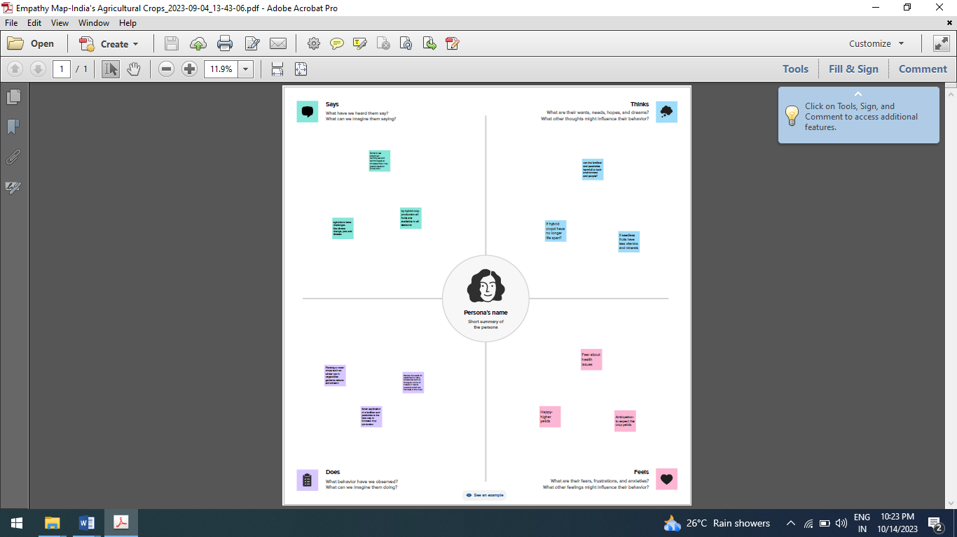

**2**.**2** **BRAIN** **STORMING**

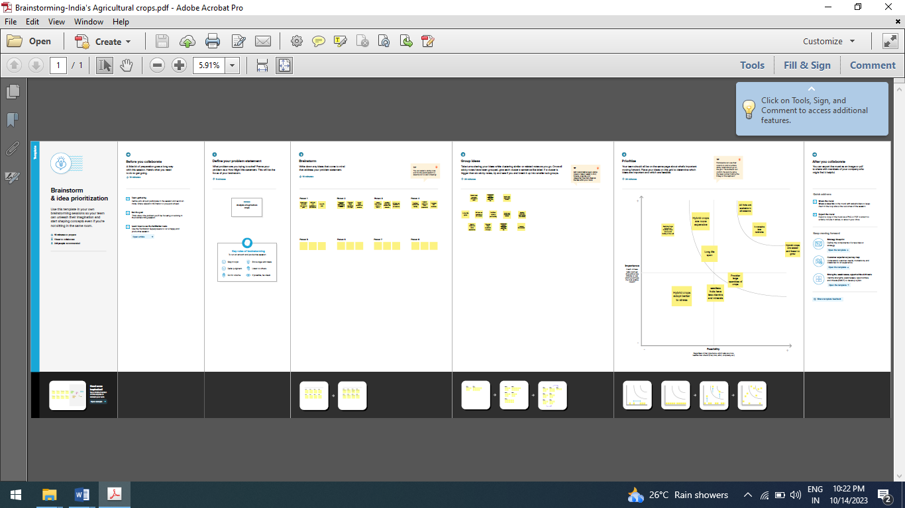

**3**.**RESULTS** :

**3**.**1** **CHARTS:**

a) Statewise Agricultural Land :

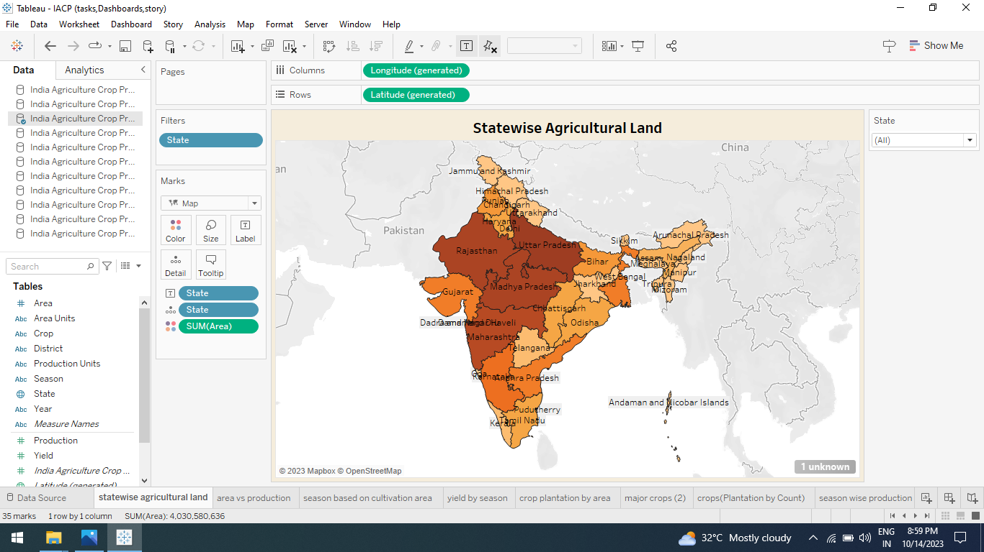

b) Yield vs Production:

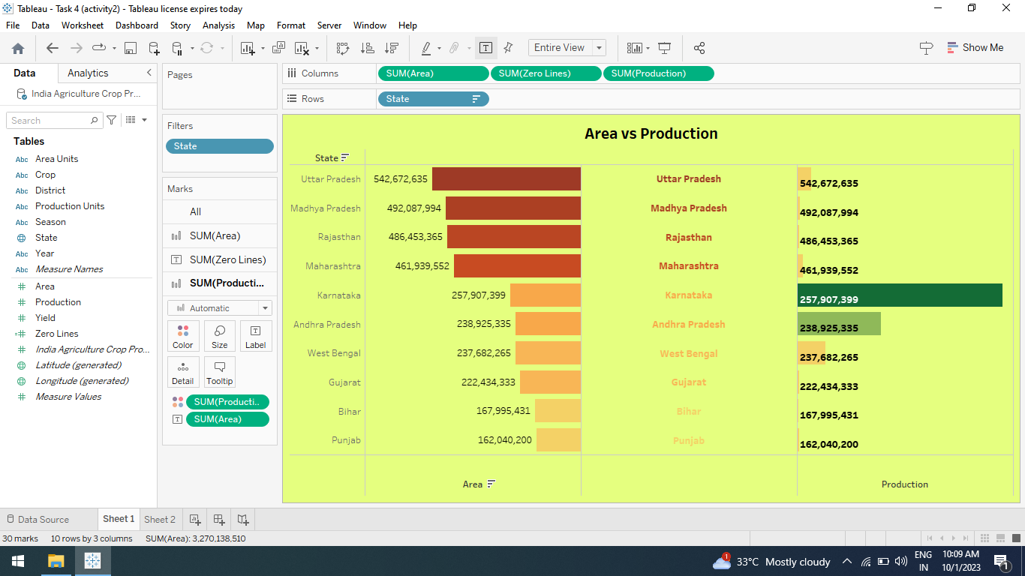

c)Season Based Cultivation :

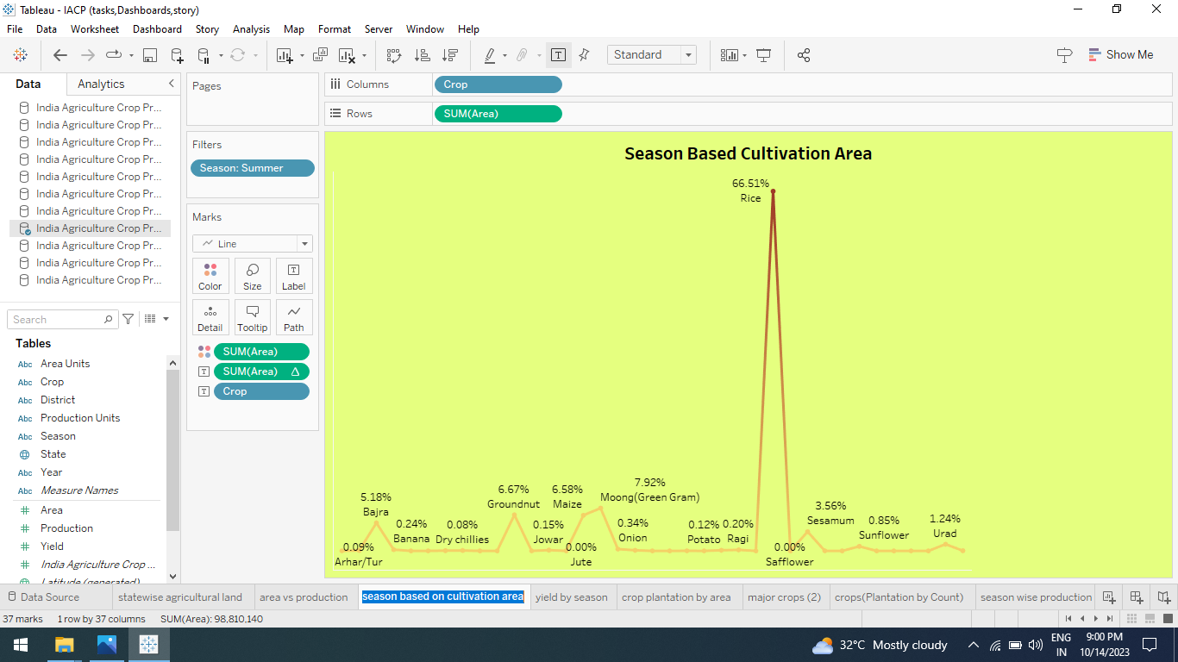

d) Yield by Season :

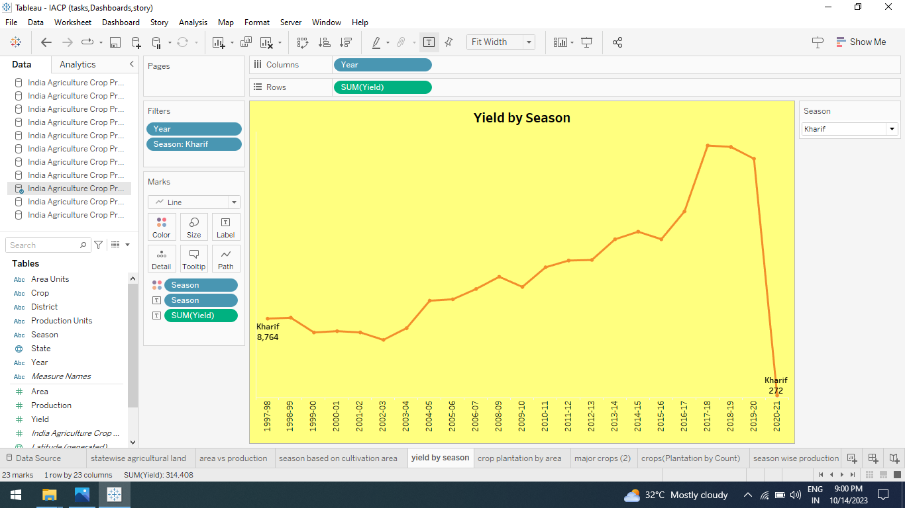

e) Crop Plantation by Area :

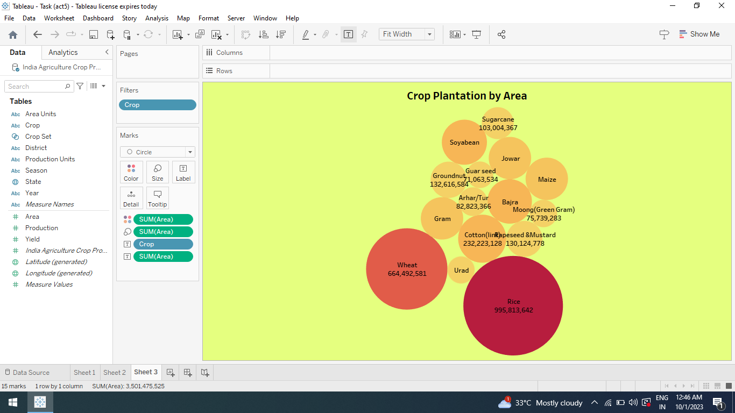

f) Major Crops :

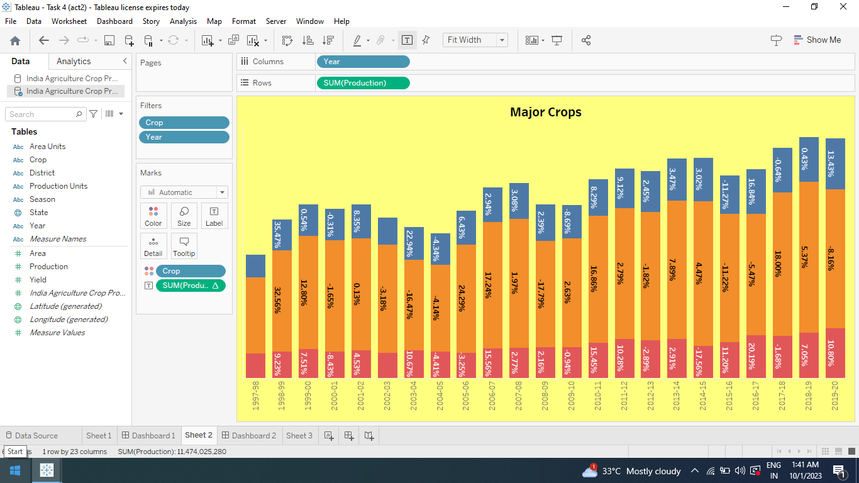

g) Crop (Plantation by Count):

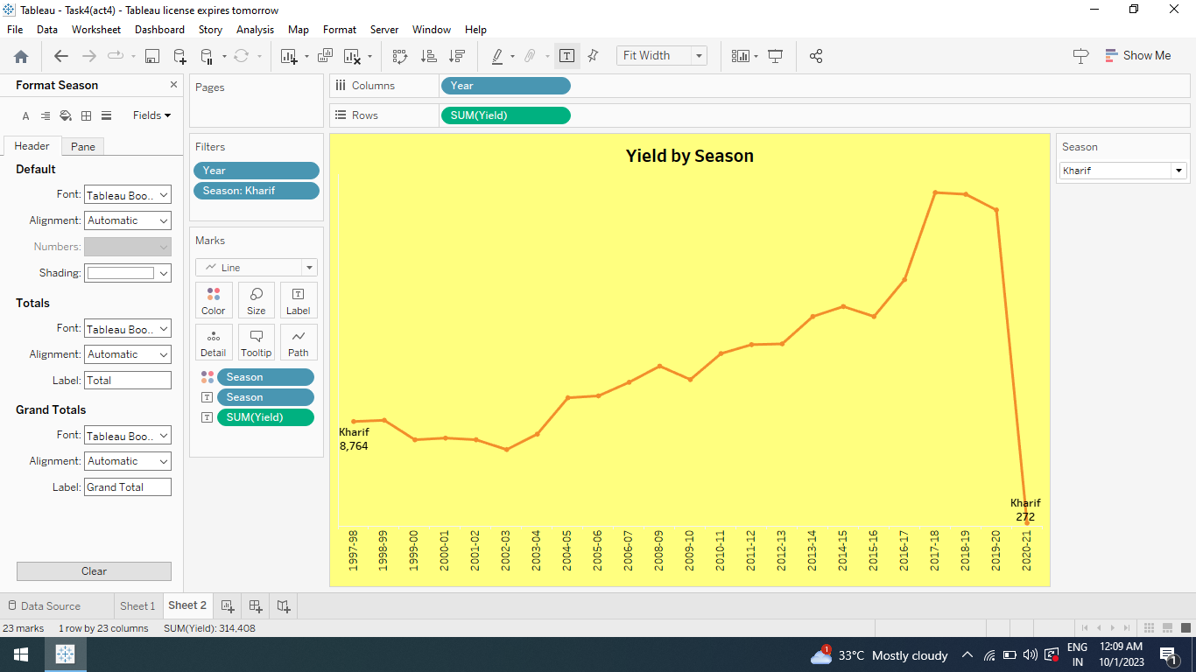

h) Season Wise Production :

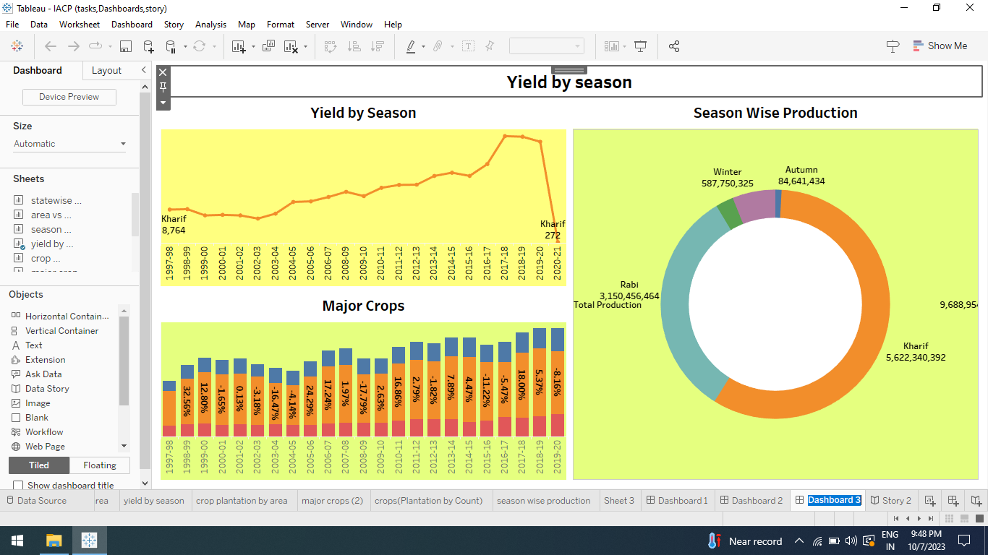

**3**.**2** **DASHBOARDS :**.

1) Area in acres Region-Wise

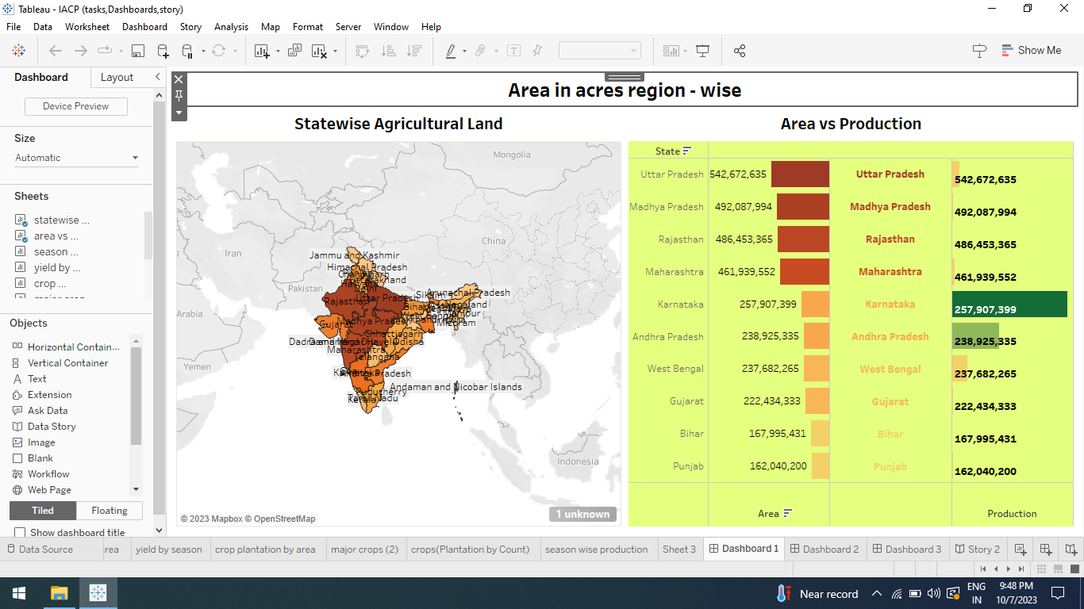

2) Production in tonnes region –Wise:

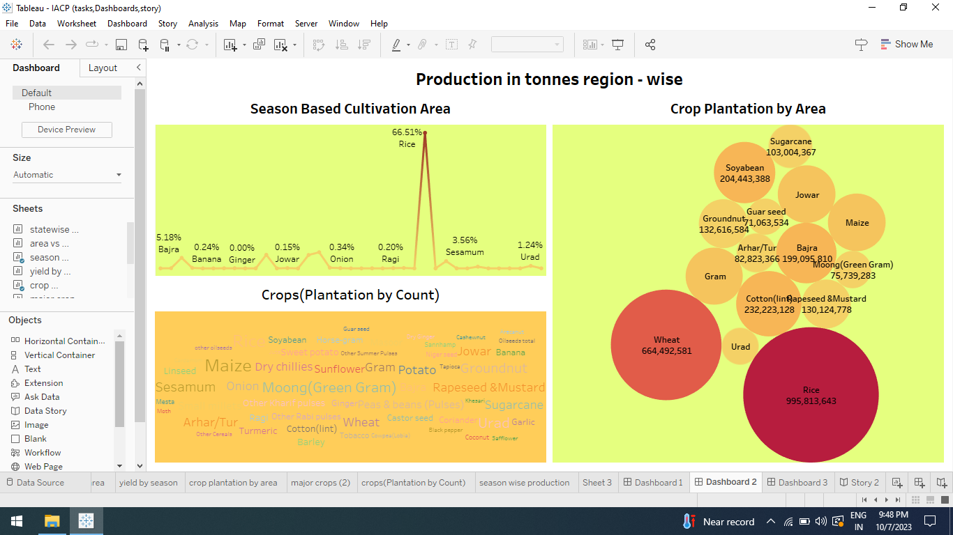

3) Yield by Season:



**3**.**3** **STORY:**

1. Insights into Indian Agricultural Cultivation

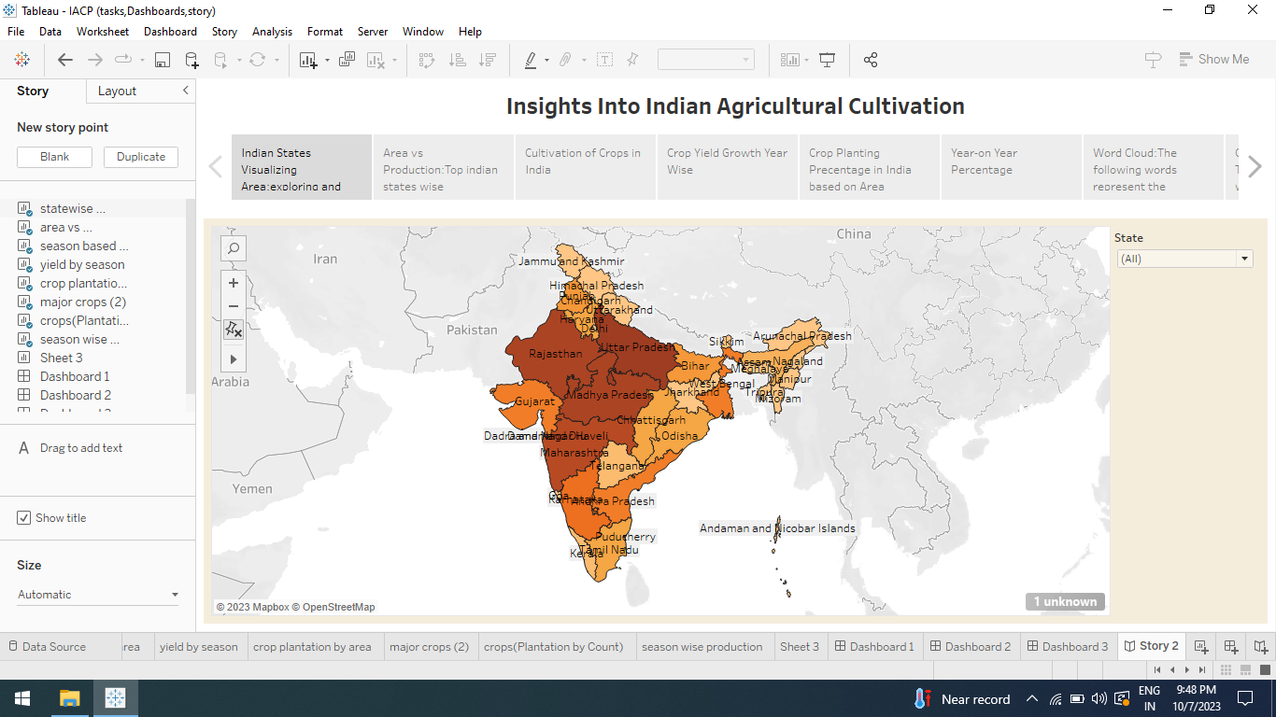

**ADVANDAGES AND DISADVANDAGES:**

**ADVANDAGES**

* Providing employment opportunities and income generation.
* The growth and productivity of agriculture sectors provide economic performance and of nation.
* Well planned production function will lead to good quality products, higher rate of production and lower cost per unit.
* Modern agriculture helps farmers to increases efficiency and reduce the use of natural resources like water, land, and energy.

**DISADVANTAGES**

* Lack of marketing events.
* Like in India, there are lack of yield development forms. This decreases the production sales in India.
* Crop deficiency can result in significant loss of plants life and harmful to human.

**APPLICATIONS**

* The information gathered from agricultural crop production is used to improve crop safety.
* Adoption of technology and innovation can helps to reduce the challenges faced by farmers.
* It offers an exciting range of seasonal fruits budget friendly.

**CONCLUSIONS**

In this project Crop Production in India is analyzed with the help of tableau. For this the data are collected from various sources. At first, we define the problem in the forms of Empathy map and Brainstroming. Then the collected to the tableau and we created various charts like tree charts, bar charts, map charts. Finally wev created dashboard and story using these charts. Also from these charts we analyzed the Crop production in various area, months and years.

**FUTURE GOAL**

* Agricultural crops analysis, will be useful to analyze the crop deficiency and enhance the crop production.
* On comparing the maximum number of crops deficiency based on years, target will be fixed in upcoming years to minimize deficiency.
* Expected tobuse advanced technologies and innovation to produce yield with limited land and resources.